Add and Update Methods

In an earlier session you should have created two stored procedures in your data layer like so...

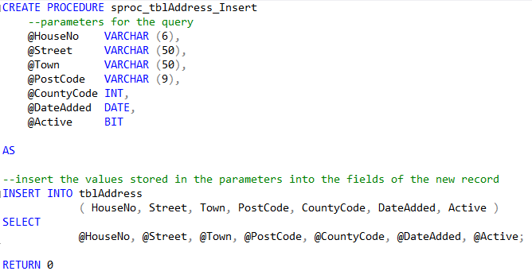

and...

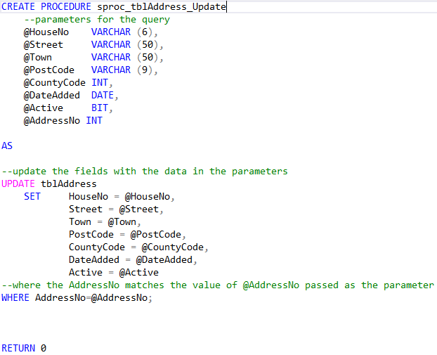

We shall now add the code allowing us to perform both of these functions from our
web application.

Much of the code should be familiar by now but there are a few things to watch out for as we add these functions.

We shall start by creating the Add method.

Creating the Add Function

The first step is to create the stub for the method in the collection class...

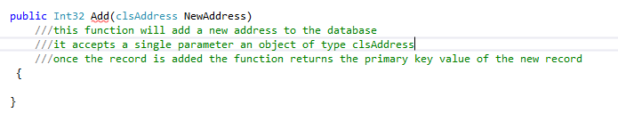

As usual the function name is underlined in red since we are yet to specify a return value.

Notice also how we are using the class clsAddress as a parameter.

We could create a parameter for each field but since the class bundles up everything in a convenient way like so.

The class looks like this...

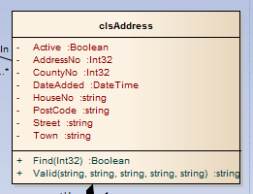

The Add function’s return data type is Integer. It will return the primary key value of any new record added.

Now that we have our function we may make use of the data connection to connect to the database.

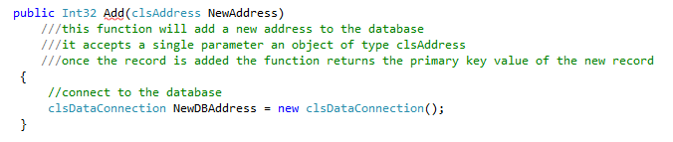

The next step is to pass the parameters to the query. (It is also a good idea to copy and paste the SQL into the function as a comment to help remind you.)

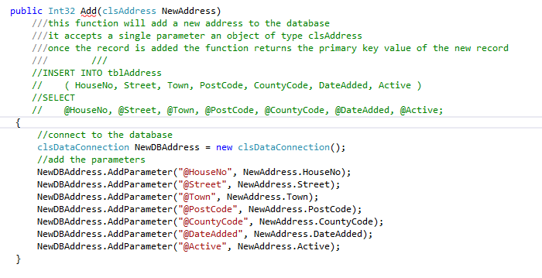

Lastly we execute the query. Since the execute method returns the primary key value of any new records we may do the following...

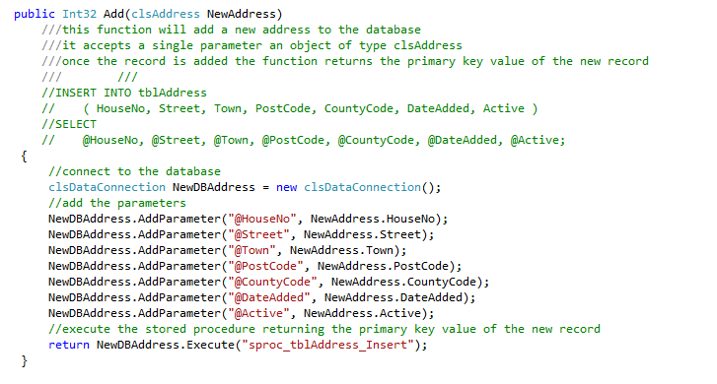

There is one last change we need to make we need to tell the stored procedure to return the primary key value by modifying it like so...

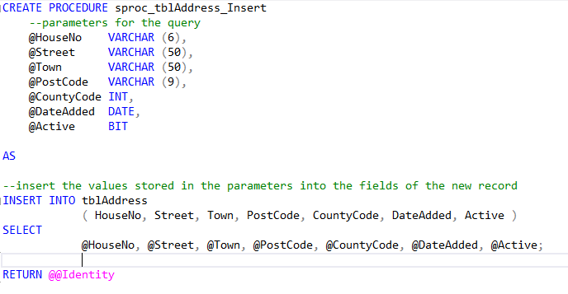
Having created the middle layer functionality the next step is to link it to the presentation layer.

Try the following code in the presentation layer...

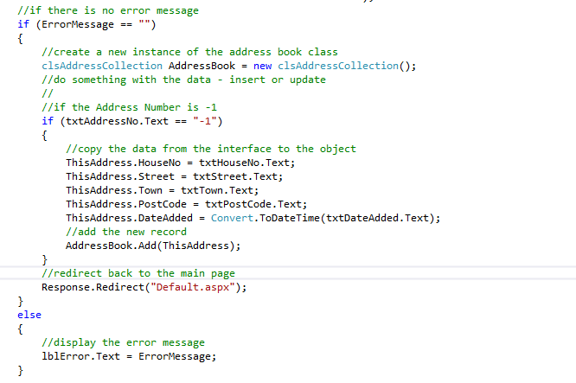

Test the code to make sure that a new record is added to the table.

Creating the Update Method

The update method is very similar to the insert method however the database needs one extra parameter. We need to pass the value of the AddressNo so that we know which record we are to update.

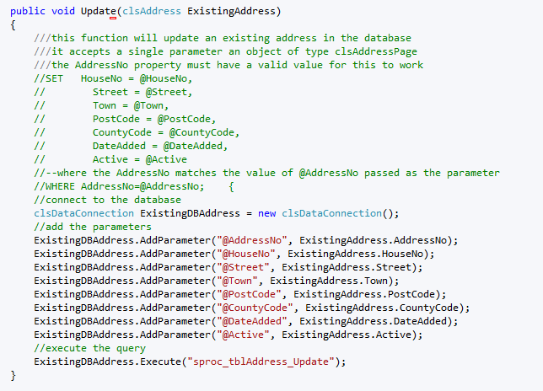

Completing the Event Handler
Now that the two functions are set up we need to build them both into the event handler for the save button.

In the case of insert if the user types an AddressNo of -1 we want the record to be added.

In the case of update however if the user types a valid integer value then we will assume it is the primary key value of an existing record and update it.

Like so...

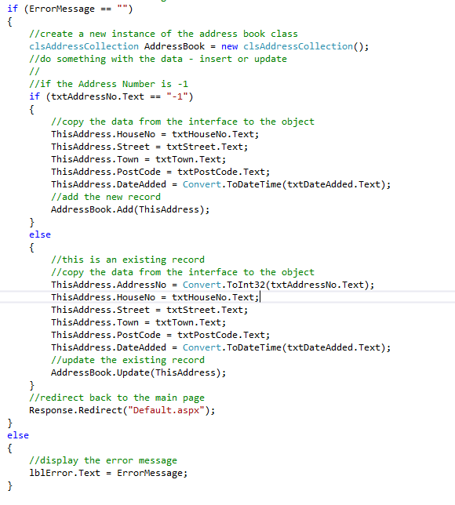

Test the program to see if you are able to insert and update records in the table.

